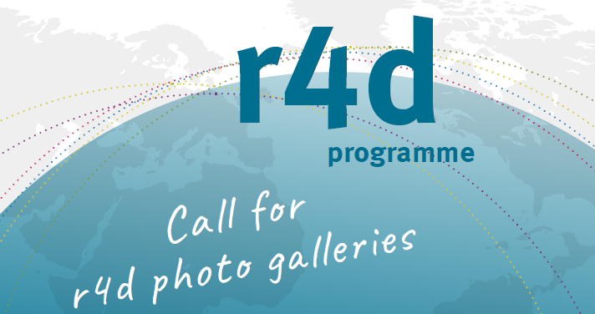

Submission dates: 15 June 2019 and 15 October 2019

Submission Form: r4d photo gallery

Date:
General information:

First name, name:
Working Address:
E-mail:

r4d research project:
r4d module:

1 Brief description of the research context from which the photo gallery emerges:
Please describe the context from which the photo gallery emerges (e.g. PhD thesis, field test, literature review) in 3-5 sentences.

2 Title of photo gallery:
Please formulate a working title (max. 80 characters including spaces).

3 Lead text:
Please provide a lead text of max. 500 characters including spaces.

4 Photo numbered with captions (min. 8 photos, max. 24 photos):
Please provide for every photo a caption of max. 400 characters including spaces.

Photo 1: …
Photo 2: …
Photo 3: …
Photo 4: …
Photo 5: …
Photo 6: …
Photo 7: …
Photo 8: …
Photo 9: …
Photo 10: …
Photo 11: …
Photo 12: …
Photo 13: …
Photo 14: …
Photo 15: …
Photo 16: …
Photo 17: …
Photo 18: …
Photo 19: …
Photo 20: …
Photo 21: …
Photo 22: …
Photo 23: …
Photo 24: …

5 Your comments:
Please feel free to leave a comment.

6 Checklist of documents and files to be submitted according to specifics of call for photo galleries:
☐ Submission form
☐ Photos numbered

Please send this submission form together with all material to r4d@snf.ch (limited to 6MB) or provide a link for complete download.

Contact for any enquiries
Claudia Zingerli, claudia.zingerli@snf.ch, +41 31 308 21 74

Claudia Rutte, claudia.rutte@snf.ch, +41 31 308 22 41

