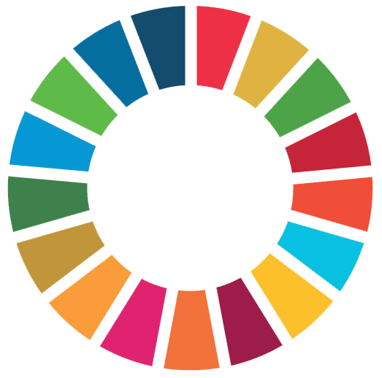
www.corp.kaltura.com

LETTER OF INTENT

I/ We, the SDG-story owner/s___________________(name/s) hereof called “Digital Storytellers” confirm in accordance with our project coordinators our participation in the r4d programme synthesis-Digital Storytellers Project. The intention of the Digital Storytellers Project is to document the r4d projects’ contributions towards achieving the Sustainable Development Goals (SDG) of the 2030 Agenda for Sustainable Development. I/We agree that by signing this agreement, I/we am/are officially welcomed into the Digital Storytellers Project and will therefore be entitled to:
- participate in the e-learning sessions qualifying for this and future media projects
- receive feedback to short e-learning assignments to gain media experience
- receive feedback/coaching to my/our SDG-story and its structure (story grid)
- make use of the filming hotline (WhatsApp or Slack Channel)
- receive coaching in selecting the equipment
- receive additional equipment pieces, if necessary
- give my/our feedback to rough cuts (1-2 feedback loops)
- have my/our final video clip color corrected with a basic sound mix
- receive credit at the end of the video clip
- place my/our finished video clip on the r4d programme Knowledge Platform

Moreover, I/we acknowledge that being part of the Digital Storytellers Project, I/we commit to:
- deliver a SDG-story and story grid before and after filming
- deliver film materials (raw material) of my/our r4d project according to the story grid and set timeline
- obtain oral or written consent by people appearing prominently in the film materials to be used in video clips for wide international online dissemination
- respect the ethical guidelines (page 2/3 )
- attempt to provide local music and approval by the musicians, when music is needed
- label and order my/our raw material following the guidance provided by the Digital Storytellers Project
- translate my/our selected interview pieces into English
- send my/our raw material to a professional editing team
- give feedback to the editing process
- authorize the r4d programme, SNSF and SDC to produce video clips for online dissemination
- agree that my/our raw material are further used in r4d synthesis programme activities (short films to be created)

Finally, I/we agree that the final versions of the video clips will be widely disseminated through multiple channels from the r4d programme to national and international policy-makers, SDG negotiators, civil society, the scientific community, and following the Creative Commons license 4.0. Copyright and rights of use of the raw material will remain with the research projects for their communication activities. The rights of the produced video clips remain with the r4D programme.

(check) I/ We have read the project conditions above, the ethical statement and filled out the technical survey and project data requirements.

Date / Name and Signature of Digital Storyteller:

Ethical Statement & Code of Conduct - Digital Storytellers Project

- Consent and Use
- Visual material is only used within the scope of the formally stated purpose to which the filmed protagonist(s) has/have given her/his/their consent. That is; the use of the material is foreseen for dissemination activities as part of the r4d synthesis, to support activities of the SDC as well as for dissemination activities within and led by the projects. This may take place through a recorded permission (audio and/or video) or a signed release form.
- Visual materials in their final edited form can only be released by the r4d Team and/or the SDC.
- Once released, the project teams are free to share the final video clips. They also keep the rights over the raw materials and may produce their own communication outlets.
- People at a site of research are previously asked for permission before any filming takes places.
- Filming children requires permission of their parents or their legal representative.

- Managing Resources
- The film team does not leave any trash related to the filming on location.
- The film team may reimburse assistance with the filming, if people have made a considerable time contribution. The same applies to reimbursing transport and food.
However, the Digital Storytellers Project does not cover these expenses. Communication budget from the projects can be used for this purpose
- The film team will not ask to re-charge batteries in local households.

- Dignity and Respect
- People living in poor conditions are shown as dignifying as possible. Eyelevel is preferred. People are never asked to show-case their poor living conditions for the camera.
- Handicaps or visual deficiencies shall only be shown if agreed and relevant for the SDG story.
- The camera is kept at a respectful distance of people being filmed (at least 1m without prior consent).
- People appear as they choose. If they ask to cover their hair or change their clothing for the camera, they shall do so. Sun glasses need to be avoided.
- People speaking to the camera in the framework of an interview or by showing a site appear with their name correctly written on-screen.
- Filming in houses or other private spaces and objects does not take place before prior consent.

- Collaboration and Participation
- People are not being asked to artificially stage a scene. However, they may be asked to repeat an action or to demonstrate it, if they are willing to.
- Suggestions for filmmaking coming from the community shall be followed, wherever it makes sense for the SDG story.
- Pressure to present themselves before the camera by other household members shall be avoided through appropriate communication of intentions.
- If people reject to answer a question, it shall be respected.

- Sensitive Content
- Sensitive content shall be recorded under the guidance of the person at stake.
- Questions on traumatic incidences require an additional consent. E.g. Would it be ok for you to talk about such and such?
- Mentioning other people with their name in the framework of sensitive or polemic content needs to be repeated without mentioning their names. It also should be made sure that a contrary perspective can be included.
- An interview setting is no place for political propaganda. Questions need to be adapted accordingly.

- Gender Sensitivity
- The filmmaking shall include an equal amount of men and women, if possible in the encountered context.
- It shall be taken into consideration that men and women may require a different approach to speak before a camera.

- Credit and local talent
- People helping with the filming will be duly credited at the end of the video clip and on the r4d Knowledge Platform. Interview partner appear with their full name unless they wish not to.

- Digital Dissemination and Copyright
- The film teams will make sure that there is no dominant radio tune playing in the back of an interview setting to avoid copyright conflict.
- Copyrights of filmed raw material remain with the r4d projects.
- Copyrights of the final video clips remain with the r4d programme, SNSF and SDC.
- Digital dissemination takes places on selected platforms and according to creative commons 4.0.
- Embedding of visual materials on any other platform (e.g. short films) requires a formal authorization by the r4d-synthesis team.
- Researchers and any other people involved are not allowed to publish the video clips on their website or social media streams before their release by the r4d programme.

- Follow-up
- Filmed protagonists are given access to see their inclusion in finished video clips. Research teams make sure that people appearing in the video clip are given access to the final video clips.

Technical Survey:
Available Camera or Smart Phone
(Brand Name, Model, Highest Recording Format, internal memory/size of available SD-Card (GB)):

Microphones (Brand Name, Model, directional/ omnidirectional:)

Tripod, Grip (Brand Name, Model)

Project Data

Name of Digital Storyteller - Main Contact:
Contact of Digital Storyteller- E-mail:
Phone Number:
Skype:
Do you use Slack? (yes/no):
Do you use Whatsapp? (yes/no):
Other Instant Messaging Service (Name)?:

Names of further team member (if applicable):

Institution:
Project Coordinator:

Research Project:
Our SDG-Story in 3 sentences:

Your preference on when to start /end your filming (optional):

Comments:

Send to digitalstoryteller@paititi-lab.org

